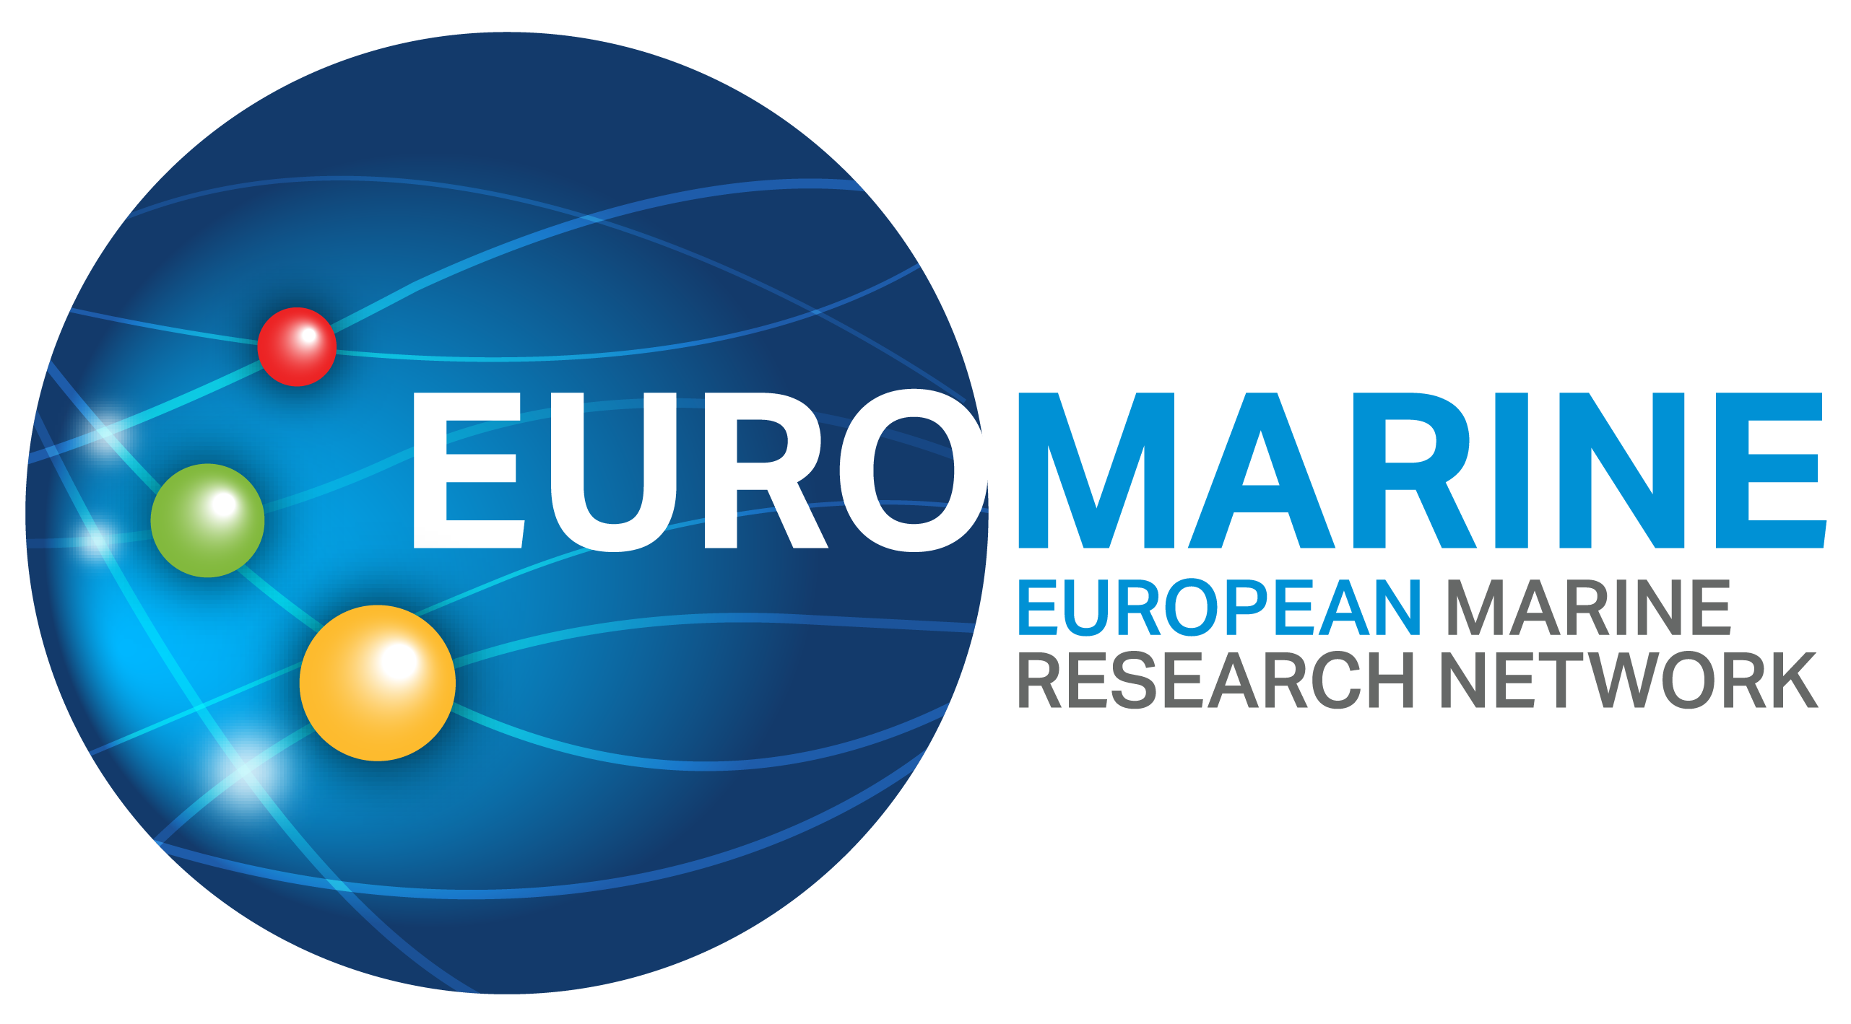

EuroMarine
Online Info Days
Organised yearly and upon request

About EuroMarine
EuroMarine is a European network of marine research organisations that promotes cooperation, foresight, and knowledge exchange to advance marine science. By supporting innovative research, early-career development, and interdisciplinary collaboration, EuroMarine fosters a strong and inclusive community committed to understanding and protecting marine ecosystems.
Purpose of the Info Days
The EuroMarine Online Info Days are designed to inform researchers, students, and stakeholders about the latest funding opportunities and services offered by the network. These sessions aim to foster connection among marine scientists, showcase successful initiatives, and encourage active participation in EuroMarine's vibrant community.
Whether you're looking for funding to launch an interdisciplinary project, curious about how others have benefitted from EuroMarine calls, or want to explore opportunities offered through the OYSTER early-career network, this event is for you.

Agenda
5min |  | Welcome & Introduction to EuroMarine
 |  | A brief overview of the network, its mission, and its role in the European marine science landscape.
15min |  | EuroMarine Funding Opportunities
 |  | Presentation of current and upcoming funding calls, including Summer Schools, Foresight Workshops, Scientific Working groups, and individual support schemes
15min |  | Spotlight on Success: Foresight Workshop Beneficiary
 |  | A past funding recipient shares their experience developing a workshop, building collaborations, and contributing to the EuroMarine community
15min |  | The OYSTER Network: Opportunities for Early-Career Researchers
 |  | Introduction to the OYSTER group, its mission, and its dedicated funding lines
15min |  | Testimonial from a Former OYSTER Fellow
 |  | A personal account of how OYSTER funding supported career development and research ambitions
15min |  | Q&A and Open Discussion
 |  | Participants will have the chance to ask questions and share thoughts

Calendar
The Info Days will be held online to allow wide participation across the EuroMarine network and beyond. The next session is scheduled for:
🗓 Monday 16th June at 11h CET
📍 Online

Registration
📍https://us06web.zoom.us/meeting/register/uWbAOXykTTuJE1bUAqGIuA

